GCCP Human Subjects Certification Program
Collaborative Institutional Training Initiative (CITI) Education
Version: 4/27/26

One of the prerequisites for the Genetic Counseling Rotation Course and Genetic Counseling Certificate Program is to complete the Human Subjects Certification Program through Collaborative Institutional Training Initiative (CITI). This course is required by anyone conducting human subject research but since all trainees in the GCCP will be observing counseling sessions, it is a prerequisite.
This course can be completed anywhere you have access to the internet. It does NOT have to be completed in one sitting. The course involves reading though some information and then completing a quiz. There are multiple sections. You must receive a high enough score to move to the next section and finally, to receive the certificate. If you do not do well on a particular quiz, you can retake it.

Once complete, send Dr. Heiman the certificate via email along with any of your other application materials.

Instructions on how to access (READ THESE CAREFULLY):
Go to this webpage: https://research.rutgers.edu/researcher-support/research-compliance/research-integrity/collaborative-institutional-training

In the middle of the page, you will see a link entitled, “How to Log in.” Click on it and follow those directions to CREATE AN ACCOUNT.

Once you log in to CITI, you need to choose “Rutgers - The State University of New Jersey (All Campuses)” – see picture below.



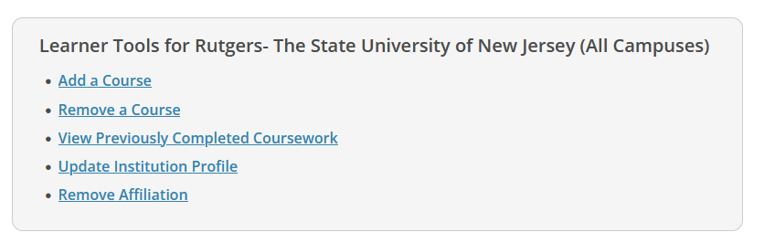

Choose “Add a course”. This will take you to another page.

On this page (Question 2), you should choose:
Human Subject Research. Then choose “NEXT”

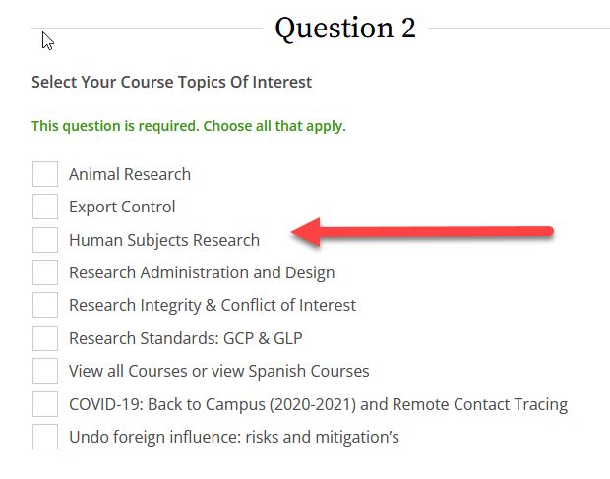

This will take you to Question 5 page. You should choose “Social & Behavioral Research Basic”

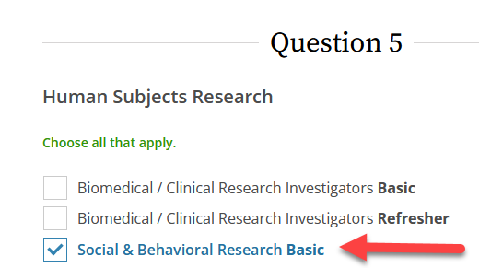

Then choose “NEXT”

This should start the course. READ THE MATERIALS CAREFULLY! If you do not do well on a particular quiz, you can retake.

If there are questions (or the CITI program has changed their webpages), contact Dr. Gary Heiman.

